SKILL-18
- To Analyze Signal Delivery, Understand Signal Masks, Review Process Groups, Explore Terminal Signals, Test Signal Behavior.
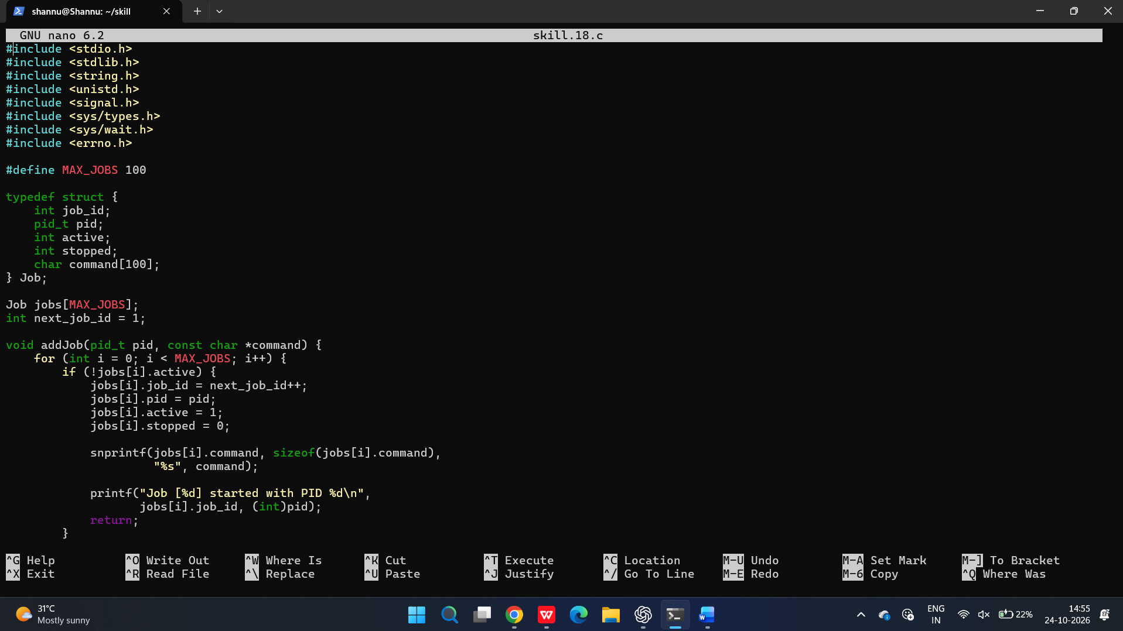
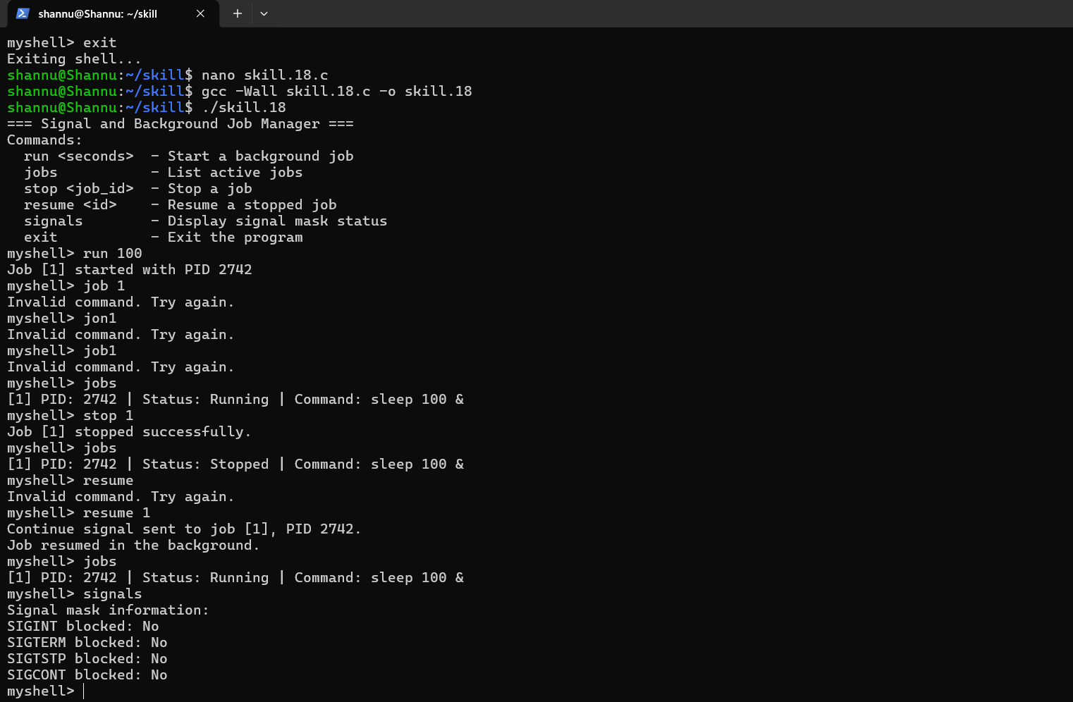

To implement how to resume Stopped Jobs, Send Continue Signals, Update Job Status, Maintain Job Table, Verify Execution, Test Background Recovery.

